it. Stcuky to good called use sympul about prepareaction of in credible,here.

**METODE**

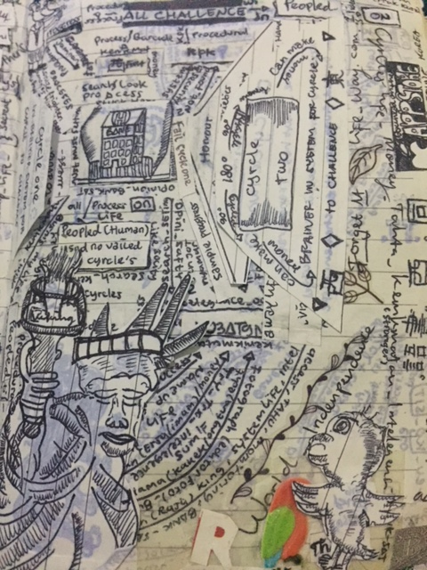The life have value use high class is a brainer never money, bitchis (but to called his) good value personality , don’t to be down which other to problem a life, also optimizem in you’re to “good human” stucky. Many a people to it, my histories looked home, School, friends,best friend so parents. The principle a life is must has to problem my goes , with begain went a reaction to people for privacy hypotesa called to example “Who “it’s me?”and Why are you life in a world, here?, also for have reaction to people want prepareaction good personality, many a people looked have trouble a life to chalence reaction. If a trouble never of chalence, must has to be a way back hypotesa with method consulate make via media social to Facebook, twitter etc. before trouble end , can also make method theraphy to free than trouble it. As for all can do it, next finishing trouble (problema), you reaction to hapinies went hystories value life memories of brainer. A reaction which hapinies, you want make personality of value than problema a life, so trouble life to example economic, husband, family, friendly etc. As a reaction to feed back you personality, went to have spirit feels, must has goes to want topic’s a life, hope good more you make worke as good value, to journalist (a writtend people) can also private teacher, may to be people activies a organitation etc. The value a trouble (problema) have credit plus personality our, credit plus as to value more the human and credible good a life. The prepareactin use value to people a way principle a life, and progress ambition for life went goes to remove a life.